## Task 1

Write c++ Program to find the positive and negative number.

Logic:

The number is positive

if number > 0

For example: 4 > 0 so 4 is a positive number

else

The number is negative

## Lab Task 2

C++ program to calculate the area of the circle

Note: Area of circle formula = 3.14*r*r;

C++ program to calculate the area of the circle

Note: Area of circle formula = 3.14*r*r;

## Lab Task 3

C++ program to check whether a character is an alphabet, digit or special character.

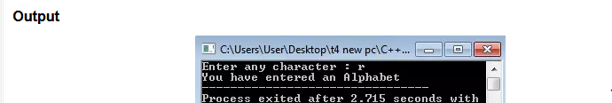

## Lab Task 4

Write a C++ program which will show first 10 members of **“series of square numbers”**. Rule for series of square number is **xn = n2.** 1, 4, 9, 16…

## Lab Task 5

Write a C++ program that will take a number as input and will display factorial of that number.

Enter number: 4

Factorial is: 24

4! = 4! = 4 × 3 × 2 × 1 = 24

## Lab Task 6

C++ program to find the sum of all integer between 100 and 200 which are divisible by 7.Also display those numbers individually.

**Output:**

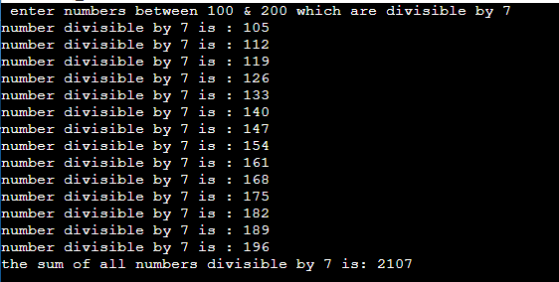

## Lab Task 7

Write a C++ Program to Find the Number of Digits Using for loop

**Output:**



## Lab Task 8

Write a program in C++ to find the Greatest Common Divisor (GCD) of two numbers.

**Output:**

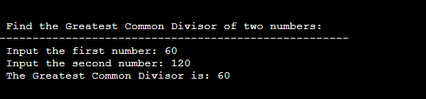

## Lab Task 9

Write a program in c++ that shows Sum of Positive Numbers Only .Take 10 inputs and user can enter negative numbers too.

**Output:**

